1.Title:
BATTLESHIP
Author: Ayan Tuladhar
Author ID: 109974948
Date: 11/29/2020

2.Program Description:
This program introduces old fashioned board game Battleship which works as a guessing game for two players. The game is played on four grids where each player gets two grids. Grids are marked to fleets of ships. Players starts the game by firing torpedoes at ships by alternating turns. As the grids are concealed from the players, they would have to guess as they are unable to see the opponent’s ships. Ships are classified into Carrier, Battleship, Cruiser, Submarine and Destroyer. The objective of the game is completed by destroying the opponent player’s entire fleet of ships.
3.Input Requirements:
This program runs on 10 by 10 square grids which are x and y coordinates. The program begins by reading the number of input files where csv file contains comma”,” separated data for ship’s type, locations and their orientations and is represented by the data type fsstream. The following steps will determine different types of data types and functions.
- Select file – option to select the file.
- Start – option to start the game.
- Column – option to enter the column player wants to shoot its torpedoes.
- Row – option to enter the row player wants to shoot its torpedoes.
- Continue – option to continue the game after the shots been hit.
- Quit – option to quit the game after the shots been hit.
- Help – option to print instructions if players needs help.
- Play Again – option to play again after the winner is determined
- Invalid Input – determines input as invalid and allow player to input it again.
Data types and functions:
- String stream – to associate string object with string.
- String – to assign sequence of characters.
- Char – to store letters.
- Boolean – to determine True or false condition.
- Try, Catch and Throw – to fix input errors (Exception handling).
4. Output Requirements:
The program displays the “Instructions” to play the game and prints the sample board as each player plays on two 10 by 10 square grids. The following steps will determine different data types and their functions.
- Ship placements – When player starts the game the program will display the message “Ships are ready” after ships placements on each player’s grids.
- Boards – The program prints the board and fleet of ships for both player and computer where computer’s ships are hidden.
- Shooting – When player, enters the co-ordinates to shoot the torpedoes at opponent’s
Grid, the appropriate markers are displayed. “X” for miss, “O” for hit and “S” for sunk.
- Tracking – When player fires the torpedoes, the program tracks the co-ordinates where the player and computer has placed their shots with the appropriate markers and display the messages.
- Invalid input – When player enters invalid input, the program prints the error message and ask the player to input again by following the guidelines.
- Winner – Displays the message “Who won” after the game is over.
- Play Again – Player enters “Y” to play again and “N” to quit the game after game is over.
The program restarts the game and displays boards, previous tracked coordinates if player decides to play again or if not, it displays the “Bye” message and end the game.
Data types and functions:
- Ifstream, fstream – to read the input(csv) file
- String – to assign sequence of characters
- Int – Integer for variable types
- Classes, constructors, mutators and accessors – to assign ship’s type, store and access them.
- Try, Catch and Throw – to fix input errors (Exception handling) and display the error messages.
- Char – to store letters.
- Boolean – to determine True or false condition.
- Inheritance – to inherit different classes.

5. Problem solution discussion:
Before the game starts the program would display all the rules to play the game and ask player to input the choice of files from the available option. This program requires to use vector as vectors are sequence containers representing arrays that can change in size. In this case, vector would be used to create the board and for classes like Grid. An example could be used from previous assignment as advised by the professor. The fsstream class would be used to both read and write from/to CSV files. In CSV (Comma Separated Values) files, data fields are separated by a comma”,” and the individual rows are separated by newline “\n”. The program follows a sequence of classes, inheritances, True/False statements etc. The two user defined data types Board and Grid contains public methods like representing row and column on XY coordinate followed by numbers and letters and getting the values of Board from Grid, deploying the sheets and printing the Grid to the screen depending on user inputs. The game starts by user inputs and the program is repeated until player or computer wins. Player has the option to quit the game after every shot and while the game is running the coordinates for shots are displayed with their appropriate markers after every shot.
Extra Credit:
This program contains requirements from extra credit/challenges where it can track all hits on a ship to determine if the ship was sunk and prints the output “you sunk my XXXship” where XXX indicates which type of ship and adds logic to the random selection of torpedo shots for the computer. The program also includes option for “HELP” where it displays instructions for the game as the player can enter “H” or “h” for help after placing the shots. Please see the attached document for UML diagram.
6. Classes, Inheritance and Data Structures:
This program includes external files (Header, Cpp, main) where it defines different classes for different functions. Classes contains constructors, mutators, inheritance etc. Some further details of classes are listed below under every program:
- Waterwar (HEADER): This program creates different ship classes where it contains list of members and it is organized by public and protected access specifier which includes get and set function for Ship’s orientation, length, number, and number of hits. It also contains Boolean expression for Ship sink.

- Board (HEADER): This program creates board class and inheritance class for player. It contains lists of members organized by access specifier public including members from “Grid10_10”, “Player” and “Waterwar” header files. It also includes operators/functions like string, fstream, sstream, Boolean expression and definition for ship’s attack, ship’s length, changing characters to integers and exception handling for input errors. In inheritance function the class inherit data members and member function. The fstream/sstream function is used to read and write lines from input files which in this case is csv file and allowing a string object to be treated as stream.

- Grid10_10 (HEADER): This program creates grid class where it contains list of members organized by public and private access specifier including members form “Grid10_10” and “Waterwar” header files. It includes vector and string function for setting ships, printing grid, firing torpedoes, checking if ship is placeable and Boolean expressions. Vector creates the 10x10 board where Boolean checks whether ships are placeable on grid or not, if the shot is hit or miss, their orientation whether the ships are Horizontal or Vertical and prints grids for both player and computer.

- Player (HEADER): This program creates player class where it contains list of members organized by public and protected access specifier including members “Grid10_10” and “Waterwar” header files. It also includes get and set function for vector, get function to print information for ships and set function to set ships on grid for player. The Boolean expression checks if player has won the game and if/else statements to check which ship is under attack and prints the name.

- Smartcomputer (HEADER): This program creates computer class and inheritance class for player This program creates computer class where it contains list of members organized by public access specifier which includes get function for grids and ships, set function for vector and generates random numbers and orientations for ships to be placed. It also contains all the members from “Grid10_10” and “Player” header files. This program sets constructors which generates random numbers and orientations for ships to be placed.

- Main (CPP): This is the main program which contains all the members from “Grid10_10”, “Waterwar”, “Board”, “Smartcomputer” and “Player” header files. It contains input/output, get/print functions and displays appropriate instructions and messages for the battleship game.

CSE GRID:
This program was successfully compiled and tested on cse grid.
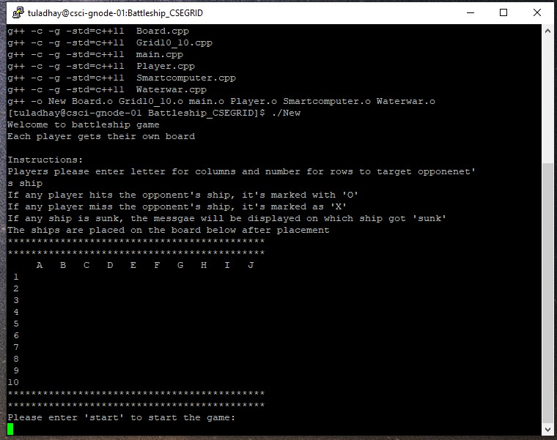

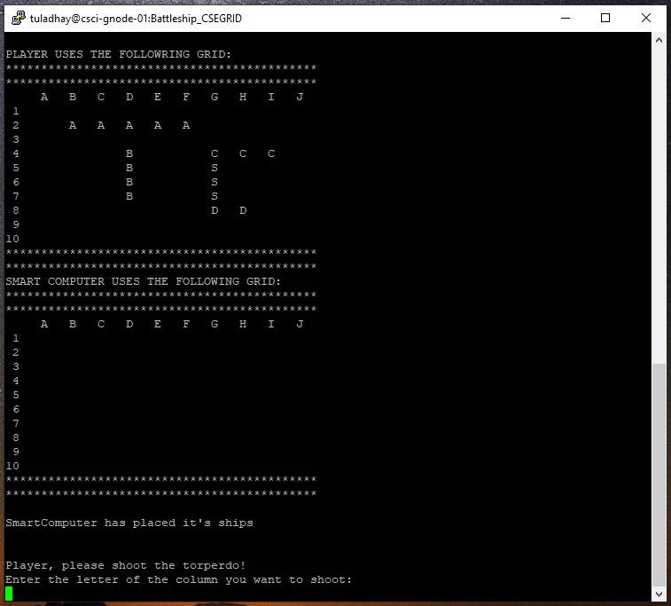

MAIN MENU
7. Overall Software Architecture
Read input files
Prints sample board and instructions for both players
START

Player starts the game when input = “start”

The Board after placing the ships for both players

SUB MENU
Exception handling:
Program checks for input errors if found, it will ask the user to input it again.

First Player shoots the torpedoes by guessing the target of opponent grid.

Computer randomly shoots torpedoes on opponent’s grid

Program checks for winner.
Repeats until one of the Player wins.

Program displays the result whether it was H, M, or S

Asking player if he/she wants to quit the game, keep playing or help

Displays the message if input is “q” for quit and “H” for help

Game continues if input = “c”

GAME OVER until one of the players wins or quits.

